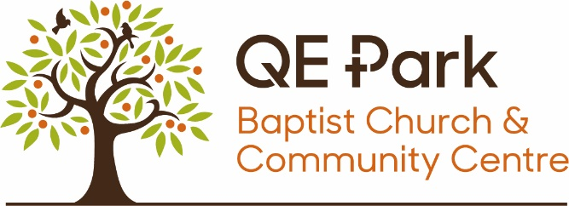

SAFEGUARDING POLICY STATEMENT FOR QE PARK BAPTIST CHURCH

Our vision
The vision statement of QE Park Baptist Church is to be a growing church in Stoughton where everyone is welcomed and together, we worship and encounter God and experience the Holy Spirit’s power; grow mature disciples of Jesus Christ and seek to share the ‘Good News’ of Jesus Christ with our community.
In fulfilling this vision, we:
- Welcome children and adults into the life of our community
- Run activities for children and adults including those who are at risk
- Make our premises available to organisations working with children and adults who are at risk
Our safeguarding responsibilities
The church recognises its responsibilities in safeguarding all children, young people and adults at risk, regardless of gender, ethnicity or ability.
As members of this church we commit ourselves to the nurturing, protection and safekeeping of all associated with the church and will pray for them regularly. In pursuit of this, we commit ourselves to this policy and to the development of sound procedures to ensure we implement our policy well.
- Prevention and reporting of abuse
It is the duty of each church member to help prevent the abuse of children and adults at risk, and the duty of each church member to respond to concerns about the well-being of children and adults at risk. Any abuse disclosed, discovered or suspected will be reported in accordance with our procedures. The church will fully co-operate with any statutory investigation into any suspected abuse linked with the church.
- Safer recruitment, support and supervision of workers
The church will exercise proper care in the selection and appointment of those working with children and adults at risk, whether paid or voluntary. All workers will be provided with appropriate training, support and supervision to promote the safekeeping of children and adults at risk.
- Respecting children and adults at risk
The church will adopt a code of behaviour for all who are appointed to work with children and adults at risk so that all children and adults are shown the respect that is due to them.
- Safer working practices
The church is committed to providing an environment that is as safe as possible for children and adults at risk and will adopt ways of working with them that promote their safety and well-being.
- A safer community
The church is committed to the prevention of bullying. The church will seek to ensure that the behaviour of any individuals who may pose a risk to children, young people and adults at risk in the community of the church is managed appropriately.

Safeguarding contact points within our church

The church has appointed the following individuals to form part of the church safeguarding team:

DAVID CUNNINGHAM, Designated Person for Safeguarding (DPS)
He will advise the church on any matters related to the safeguarding of children and adults at risk and take the appropriate action when abuse is disclosed, discovered or suspected.

Phone number 07905 827999 Email address climberdave@virginmedia.com

KATE MORRIS, Deputy Designated Person for Safeguarding (DDPS)
She will assist the Designated Person for Safeguarding (DPS) in helping the church on any matters related to the safeguarding of children and adults at risk and take the appropriate action when abuse is disclosed, discovered or suspected.

Phone number 07427 634630 Email address 25katemorris@gmail.com

KATE WHITING, Safeguarding Trustee
She will raise the profile of safeguarding within the church and oversee and monitor the implementation of the safeguarding policy and procedures on behalf of the church trustees.

Phone number 07805 191029 Email address kate.whiting@qeparkbaptist.org.uk

Our church minister is also an important part of the Church Safeguarding Team. Where possible, the Church Safeguarding Team will work together if and when issues arise. However, each person has a responsibility to report allegations of abuse as soon as they are raised.

Further definitions of these roles can be found in the BUGB publications ‘Safe to Grow’ (2011) & ‘Safe to Belong’ (2015).

Putting our policy into practice
- A copy of the safeguarding policy statement will be displayed permanently on the church noticeboard and church office, and is available on our church website.
- Each worker with children and/or adults at risk will be given a full copy of the safeguarding policy and procedures and will be asked to sign to confirm that they will follow them.
- A full copy of the policy and procedures will be made available on request to any member of, or other person associated with the church.
- The policy and procedures will be monitored and reviewed annually, and any necessary revisions adopted into the policy and implemented through our procedures.
- The policy statement will be read annually at the church AGM, together with a report on the outcome of the annual safeguarding review.

Next review is due: JUNE 2024

