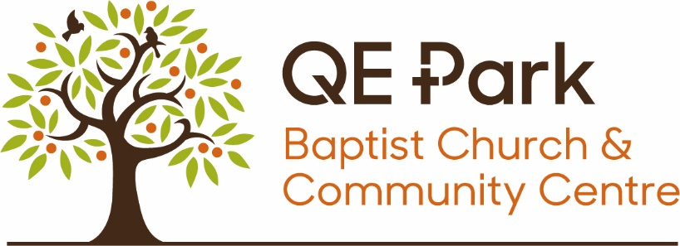
Lettings Policy
The QE Park Centre is owned and managed by QE Park Baptist Church which is a Registered Charity (Charity Number 1166680) whose principal purpose is:
The advancement of the Christian faith according to the principles of the Baptist denomination. The Church may also advance education and carry out other charitable purposes in the United Kingdom and/or other parts of the world.

We therefore gladly share the building with other Christian organisations and individuals that share similar aims.

The Centre is also available for use by members of the wider community.

The building is registered as a place of Christian worship and it is our hope and prayer that the QE Park Centre is a place where people can find a warm welcome and discover more about the Christian faith if they want to. We ask that all those using the Centre are respectful of our faith journey and the principles which underpin it even if they do not agree with them.

On occasions, we may receive a request that seems to be at odds with the Christian Gospel. If this happens, we will ask potential hirers if we might talk to them about the difficulty that has arisen. In the event that our Charity Trustees consider that the proposed use cannot be reconciled with our charitable purpose we reserve the right to decline the booking.

As a registered place of worship, it may occasionally be necessary to cancel lettings for special on off events (e.g., community outreach event, wedding, or funeral). On such occasions we will give regular hirers as much notice as possible and a refund will be issued.

December 2023

